Explore Tor network for anonymous communication 231901005

AIM:

A beginner orienteered guide on using the Tor network.

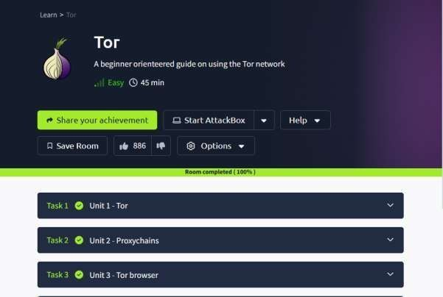

TASK 1 : UNIT 1 – TOR

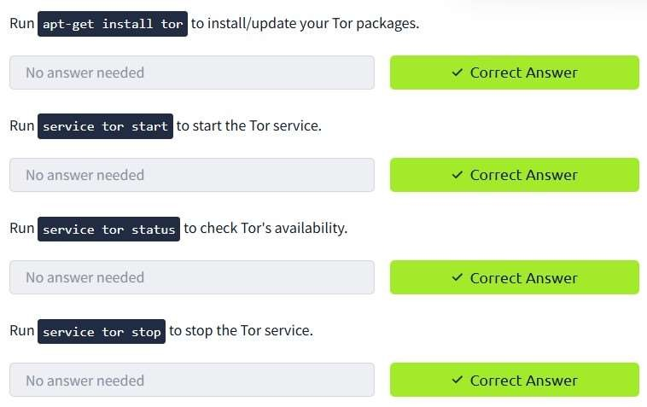

TASK 2 : UNIT 2 PROXYCHAINS

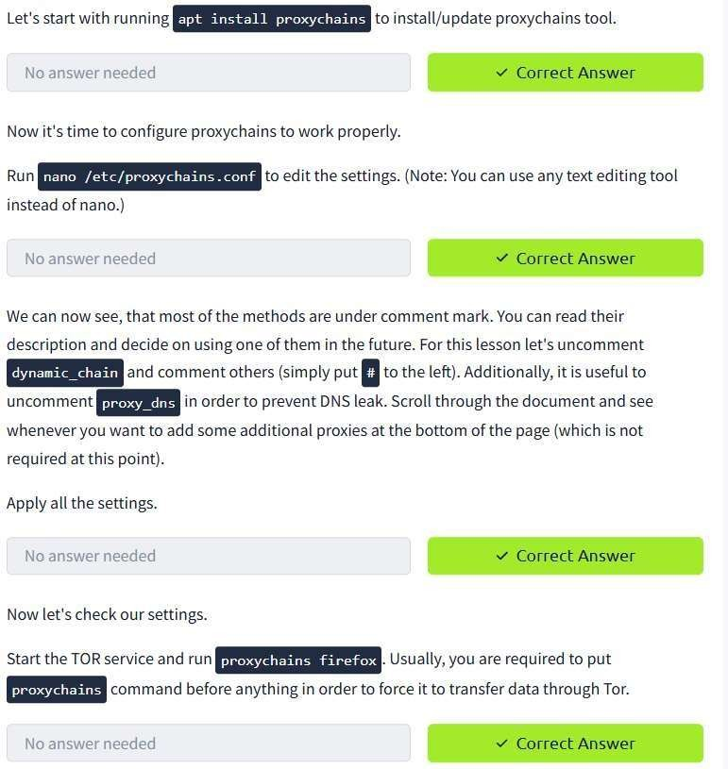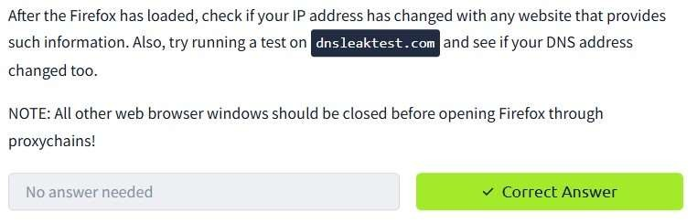

TASK 3 : UNIT 3 – TOR BROWSER

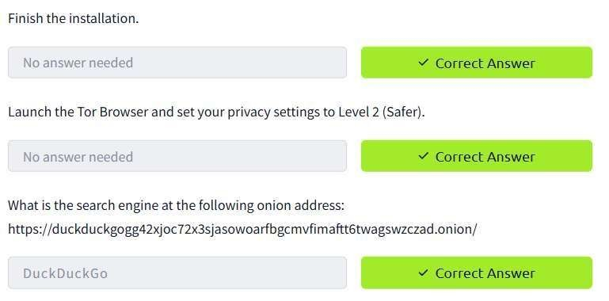

CONCLUSION :

Explore Tor network for anonymous communication task successfully complete.